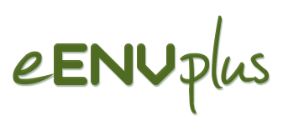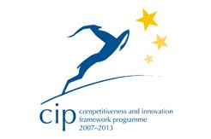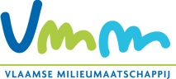

eENVplus Workshop & General Meeting
Leuven (BE), 18 September 2013

-REGISTRATION FORM-

Please fill out and return this form by 13th of September 2013 to the
Flemish Environment Agency
(e-mail: p.dewit@vmm.be)

Name:
First Name:
Organisation:
Address:
Country:
E-mail:
Dietary requirements (e.g. food allergies, vegetarian food)

I will attend:

Wednesday 18nd September 2013

10:00 – 13:00: Workshop | YES/NO
13:00 – 14:00: Lunch | YES/NO
14:00 – 16:45: Open Project Meeting | YES/NO
18:45 – 21:30: Conference Dinner | YES/NO

